**HOSPITAL MANAGEMENT SYSTEM**

SQL PROJECT

BY PRUTHIKA WANKAR

INTRODUCTION :

A Hospital Management System (HMS) is an organized information system designed to manage the administrative aspects of a hospital. This organized system aims at operations, enhance patient care, and improve the management of health information across the hospital. Here's a detailed description:

* To enhance system by providing easy access to patient data.
* To improve operational efficiency by automating tasks.
* To ensure each and everything is in organized database.
* Hms is for managed data of each department which includes with it.

WHY IS THIS IMPORTANT?

Handles patient appointment, appointment scheduling, and patient tracking through various departments. Billing and payment tracking, and financial reporting, ensuring accuracy and efficiency. Enables quick access to patient records, reducing errors and enhancing the quality of care. This helps reducing manual work and increasing productivity.

In summary, a Hospital Management System is a vital tool that integrates various aspects of hospital operations, aiming to improve the efficiency of healthcare delivery, enhance patient care, and optimize resource management.

This database contains 8 tables :

1. PATIENT
2. DOCTOR
3. NURSE
4. APPOINMENT
5. STAFF
6. ROOM
7. PHARMACY
8. BILL

How these tables are connected to each other are shown in the following er diagram :

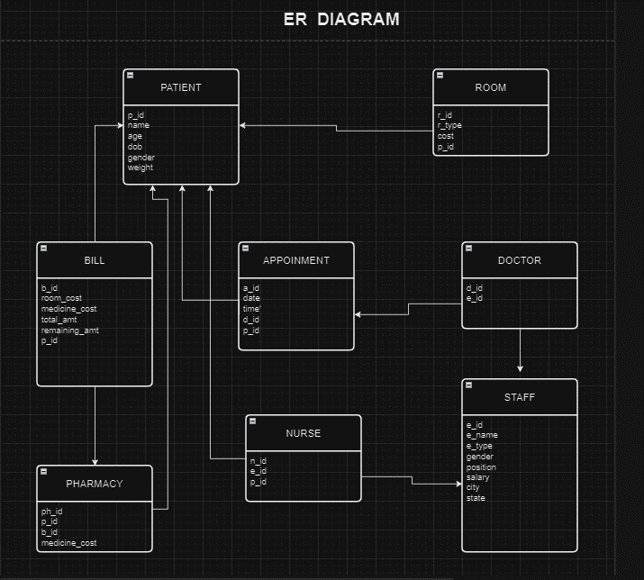

**DATA FORMAT AND CREATION OF TABLES :**

|  |  |  |
| --- | --- | --- |
| NAME | ATTRIBUTES | DATATYPES |
| PATIENT | p_id | int |
| name | varchar(20) |
| age | int |
| dob | date |
| gender | varchar(5) |
| weight | float |

create table Patient(p_id int primary key, name varchar(20),age int, dob date, gender varchar(5),weight float);

|  |  |  |
| --- | --- | --- |
| NAME | ATTRIBUTES | DATATYPES |
| STAFF | e_id | int |
| e_name | varchar(50) |
| e_type | varchar(50) |
| gender | varchar(10) |
| position | varchar(50) |
| salary | float |
| city | varchar(40) |
| state | varchar(40) |

create table staff(e_id int primary key,e_name varchar(50), e_type varchar(50),gender varchar(10),position varchar(50),salary float,city varchar(40),state varchar(40));

|  |  |  |
| --- | --- | --- |
| NAME | ATTRIBUTES | DATATYPES |
| DOCTOR | d_id | int |
| e_id | Int (FK) |

create table doctor(d_id int primary key not null,e_id int, foreign key(e_id) references staff(e_id));

|  |  |  |
| --- | --- | --- |
| NAME | ATTRIBUTES | DATATYPES |
| NURSE | n_id | int |
| p_id | Int (FK) |
| e_id | Int (FK) |

create table nurse(n_id int primary key ,p_id int, foreign key(p_id) references Patient(p_id), e_id int, foreign key(e_id) references staff(e_id));

|  |  |  |
| --- | --- | --- |
| NAME | ATTRIBUTES | DATATYPES |
| APPOINMENT | a_id | int |
| date | date |
| time | time |
| d_id | Int (FK) |
| p_id | Int (FK) |

create table appoinment(a_id int primary key , date date, time time, d_id int ,foreign key(d_id) references doctor(d_id), p_id int , foreign key(p_id) references patient(p_id));

|  |  |  |
| --- | --- | --- |
| NAME | ATTRIBUTES | DATATYPE |
| ROOM | r_id | int |
| r_type | varchar(20) |
| r_cost | float |
| p_id | Int (FK) |

create table room(r_id int not null ,r_type varchar(20),r_cost float, p_id int, foreign key(p_id) references patient(p_id));

|  |  |  |
| --- | --- | --- |
| NAME | ATTRIBUTES | DATATYPE |
| BILL | b_id | int |
| r_cost | float |
| medicines_cost | float |
| total_amt | float |
| remaining_amt | float |
| p_id | Int (FK) |

create table bill(b_id int primary key , r_cost float, medicines_cost float, total_amt float, remaining_amt float, p_id int, foreign key(p_id) references patient(p_id));

|  |  |  |
| --- | --- | --- |
| NAME | ATTRIBUTES | DATATYPE |
| PHARMACY | ph_id | int |
| medicines_cost | float |
| p_id | Int (FK) |
| b_id | Int (FK) |

create table pharmacy(ph_id int primary key, medicines_cost float, p_id int, foreign key(p_id) references patient(p_id),b_id int, foreign key(b_id) references bill(b_id));

**COMMANDS AND INSERTING VALUES :**

**CREATE DATABASE :**

Create database hospital_management_sys;

**SELECT DATABASE:**

use hospital_management_sys;

**CREATE TABLES :**

**PATIENT TABLE :**

insert into Patient values(1,'swara das', 19,'2004-12-24', 'f', 43),(2,'pruthika wankar',20,'2003-12-21','f', 45),(3, 'emily jones', 24,'2001-11-20','f',50),(4,'chris davis',25,'1990-02-25','m',61),(5, 'john williams', 30,'1995-06-18','m' ,72);

**STAFF TABLE :**

insert into staff values(101,'hinda lee','doctor','f','MD', 40000, 'mumbai','maharashtra'),(102,'nina davis','nurse','f','head nurse', 21000, 'mumbai','maharashtra'),(103,'vikram raut','doctor','m','MD', 620000, 'mumbai','maharashtra'),(104,'arul shetty','doctor','m','m', 120000, 'mumbai','maharashtra'),(105,'parnika shetty','nurse','f','Nurse Practitioner', 5000, 'mumbai','maharashtra');

**DOCTOR TABLE :**

insert into doctor values(01,103),(02,101),(03,104);

**NURSE TABLE :**

insert into nurse values(001,3,102),(002,1,105),(003,2,105),(004,5,102),(005,4,102);

**APPOINMENT TABLE :**

insert into appoinment values(0001, '2024-03-23','1:00',1,1),(0002, '2024-03-23','1:10', 2, 2),(0003,'2024-03-23','1:20', 3, 4),(0004,'2024-03-23','2:40', 2, 3),(0005,'2024-03-23','2:15',1, 5);

**ROOM TABLE :**

insert into room values(111, 'general room',500.00,5),(112,'icu room',1300.00,4),(113,'private room', 2500.00, 3),(114, 'general room', 500.00,2),(115, 'private room', 2500.00,1);

**BILL TABLE :**

insert into bill values(101, 500, 100, 600, 500,5),(102, 1300, 500,1800, 1200,4),(103, 2500, 1000, 3500, null,3),(104,500,200,700, 50,2),(105, 2500, 2000, 4500, null,1);

**PHARMACY TABLE :**

insert into pharmacy values(1, 2000, 1,105),(2, 200, 2,104),(3, 1000, 3,103),(4, 500, 4,102),(5, 100, 5,101);

**QUERIES :**

1. **Select position of staff who ‘s gender is male :**

select count(e_id),position from staff where gender in('m')group by position;

|  |  |
| --- | --- |
| eid | positions |
| 1 | MD |
| 1 | Neurologist |

1. **Select the patients who has not paid the remaining amount :**

select * from bill where remaining_amt is not null;

|  |  |  |
| --- | --- | --- |
| B_id | Remaining_amt | P_id |
| 101 | 500 | 5 |
| 102 | 1200 | 4 |
| 104 | 50 | 2 |

1. **Select the count of rooms :**

select count(r_id),r_type from room group by r_type;

|  |  |
| --- | --- |
| R_id | R_type |
| 2 | General room |
| 1 | Icu room |
| 2 | Private room |

**JOINS :**

1. **Select patient’s appoinment time and date :**

select patient.name, appoinment.time, appoinment.date from patient natural join appoinment;

|  |  |  |
| --- | --- | --- |
| NAME | TIME | DATE |
| swara das | 01:00:00 | 2024-03-23 |
| pruthika wankar | 01:10:00 | 2024-03-23 |
| emily jones | 02:40:00 | 2024-03-23 |
| chris davis | 01:20:00 | 2024-03-23 |
| john williams | 02:15:00 | 2024-03-23 |

1. **select particular patients’s bill :**

select * from patient natural join bill;

|  |  |  |  |  |  |  |  |  |  |  |
| --- | --- | --- | --- | --- | --- | --- | --- | --- | --- | --- |
| P_id | name | age | dob | gender | weight | B_id | R_cost | Medic  Ine_cost | Total_amt | Remaini  Ng_amt |
| 1 | swara das | 19 | 2004-12-24 | f | 43 | 105 | 2500 | 2000 | 4500 | null |
| 2 | pruthika wankar | 20 | 2003-12-21 | f | 45 | 104 | 500 | 200 | 700 | 50 |
| 3 | emily jones | 24 | 2001-11-20 | f | 50 | 103 | 2500 | 1000 | 3500 | null |
| 4 | chris davis | 25 | 1990-02-25 | m | 61 | 102 | 1300 | 500 | 1800 | 1200 |
| 5 | john williams | 30 | 1995-06-18 | m | 72 | 101 | 500 | 100 | 600 | 500 |

1. **select which patient is in which type of room :**

select patient.name , room.r_type from patient natural join room

|  |  |
| --- | --- |
| NAME | R_TYPE |
| swara das | private room |
| pruthika wankar | general room |
| emily jones | private room |
| chris davis | icu room |
| john williams | general room |

**HMS Project Conclusion**

**I have successfully completed the HMS project, achieving key goals in enhancing hospital operations and patient care through my SQL-based system. Successfully implemented a easy SQL database schema supporting needed data. This automated operation will reduces patient processing time.**

**THANK YOU!**